**ACKNOWLEDGEMENT**

It is indeed with a great pleasure and immense sense of gratitude that we acknowledge the help of these individuals. We are highly indebted to our Dean **Dr. Niraj Shah**, Dean, School of Engineering, P P Savani University, for the facilities provided to accomplish this minor project.

We feel elated in manifesting our sense of gratitude to our project guides Mr. Mitul Raj. He/ She has been a constant source of inspiration for us and we are very deeply thankful to him for his support and valuable advice

We extremely grateful to our Departmental staff members, Lab technicians and Non-teaching staff members for their extreme help throughout our project.

Finally we express our thanks to all of our friends who helped us in successful completion of this project.

**Yashraj Gohil (18SE02IT012)**

**Fenil Savani (18SE02IT052)**

**ABSTRACT**

Online Library Management System is a system which maintains the information about the books present in the library, their authors, the members of library to whom books are issued, library staff and all. This is very difficult to organize manually. Maintenance of all this information manually is a very complex task. Owing to the advancement of technology, organization of an Online Library becomes much simple. The Online Library Management has been designed to computerize and automate the operations performed over the information about the members, book issues and returns and all other operations. The system would provide basic set of features to add/update members, add/update books, and manage check in specifications for the systems . This computerization of library helps in many instances of its maintenances. It reduces the workload of management as most of the manual work done is reduced

**INDEX**

1. INTRODUCTION

1.1 Introduction

1.2 Problem introduction

1.3 Objective

2. REQUIREMENTS SPECIFICATION

2.1 Introduction

2.2 Hardware requirements

2.3 Software requirements

3. ANALYSIS

3.1 Existing System

3.2 Proposed System

4. SYSTEM IMPLEMENTATION

5.1 Sample code

5. SAMPLE SCREENSHOTS

6. CONCLUSION AND FUTURE SCOPE

REFERNCES

CHAPTER 1

**INTRODUCTION**

* 1. **Introduction**

The project titled Library Management System is Library

Management software for monitoring and controlling the transactions in a library .The project “Library Management System” is developed in SAP , which mainly focuses on basic operations in a library like adding new books, and updating new information, searching books and members and return books.

This project of “LIBRARY MANAGEMENT” of gives us the complete information about the library. We can enter the record of new books and retrieve the details of books available in the library. We can issue the books to the students and maintain their records and can also check how many books are issued and stock available in the library. In this project we can maintain the late fine of students who returns the issued books after the due date.

Throughout the project the focus has been on presenting information and comments in an easy and intelligible manner. The project is very useful for those who want to know about Library Management System.

* 1. **Problem Introduction**

The current Library Management System does not eliminate the process of searching books within the library campus. Students have to find books manually. They have to wait until they are not provided with their library card and token. For receiving book they have to show their library card and wait in line for their turns. The admin personnel also have to look manually on which day which person will take the charge within library to manage the overall work.

* 1. **Objective**

Proposed system is an automated Library Management System. Through our software user can add books, search books, renewal, update information, edit information, and return books in quick time. Our proposed system has the following advantages.

. User friendly interface

. Fast access to database

. Less error

. More Storage Capacity

. Search facility

. Look and Feel Environment

CHAPTER 2

**REQUIREMENT SPECIFICATION**

**2.1 Introduction**

This project is completely based on ABAP language of SAP world. ABAP is a high level programming language created by SAP that helps large corporations to customize the SAP ERP. ABAP stands for Advanced Business Application Programing.

* 1. **Hardware requirements**

**Windows-based PC** running Windows 7, Vista, or Windows XP with Service Pack 3 with minimum 2 GB RAM.

**Apple Mac** with Virtual Machine software (VMWare, Fusion, Parallels) running Windows 7, Vista, or XP with minimum 2 GB RAM.

* 1. **Software requirements**
* SAP GUI 7.30
* SAP IDES 4.7 Installation files

CHAPTER 3

**ANALYSIS**

**3.1 Existing System**

Early days Libraries are managed manually. It required lot of time to record or to retrieve the details. The employees who have to record the details must perform their job very carefully. Even a small mistake would create a lot of problems. Security of information is very less. Report generations of all the information is very tough task.  Maintenance of Library catalogue and arrangement of the books to the catalogue is very complex task. In addition to its maintenance of member details, issue dates and return dates etc. manually is a complex task.  All the operations must be performed in perfect manner for the maintenance of the library with out any degradation which may finally result in the failure of the entire system.

**3.2 Proposed System**

To solve the inconveniences as mentioned in the existing system, an **Online Library** is proposed. The proposed system contains the following features: ○

* Book details like authors, number of copies totally maintained by library, present available number of books, reference books, non-reference books etc. all this information can be made handy. ○
* Regarding the members designation, number of books was issued.
* Issue dates and returns of each member is maintained separately and fine charged if there is any delay in returning the book. ○
* Administrator can add, update the books.
* Time consuming is low, gives accurate results, reliability can be improved with the help of security

CHAPTER 4

**SYSTEM IMPLEMENATION**

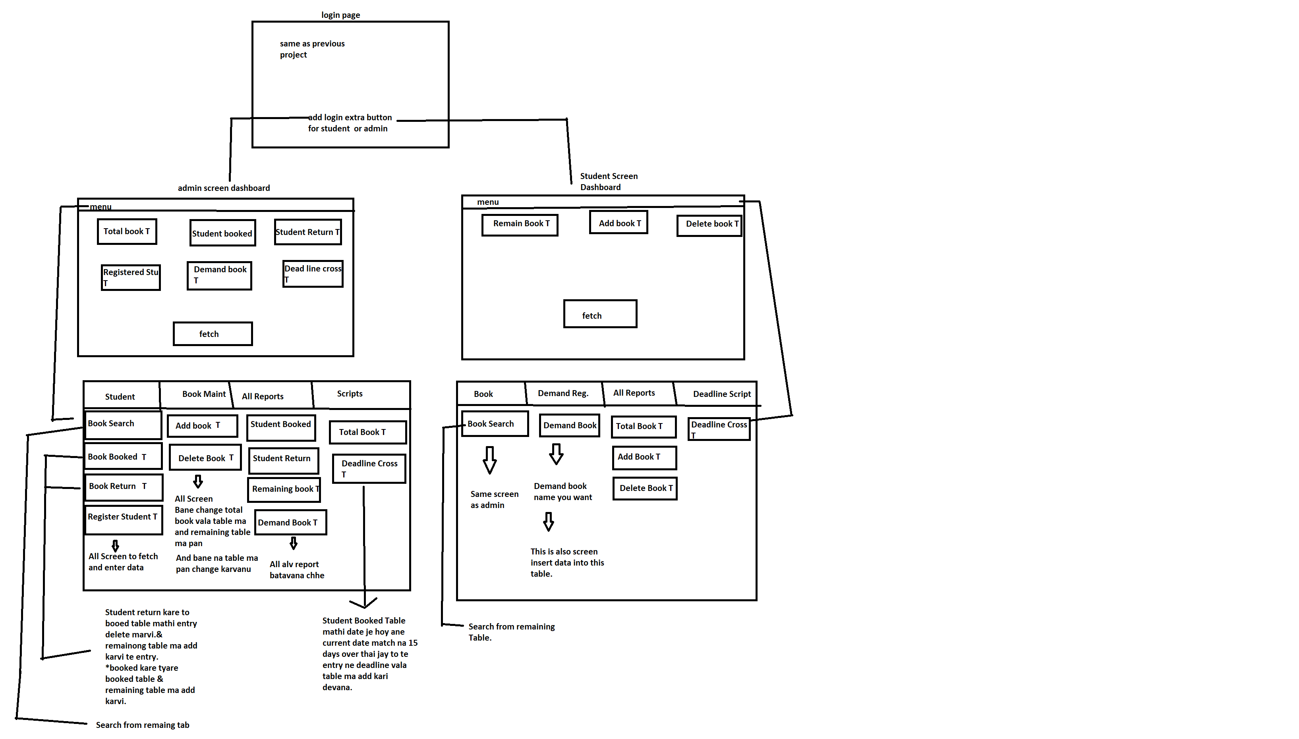

CHAPTER 5

**SAMPLE SCREENSHOTS**

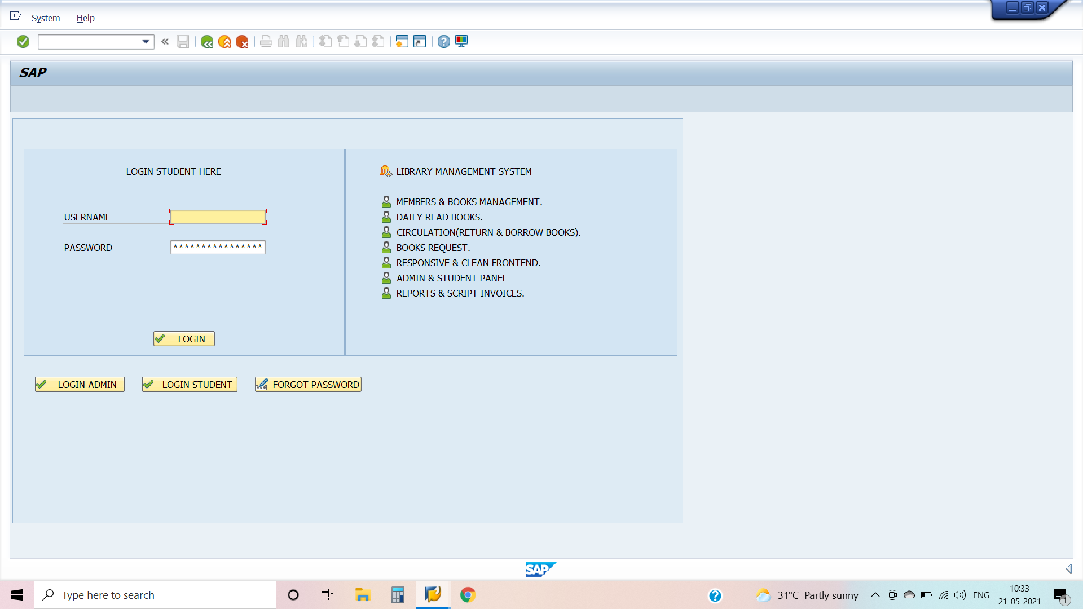

**5.1 Main Page(login)**



**5.2 Dashbord**

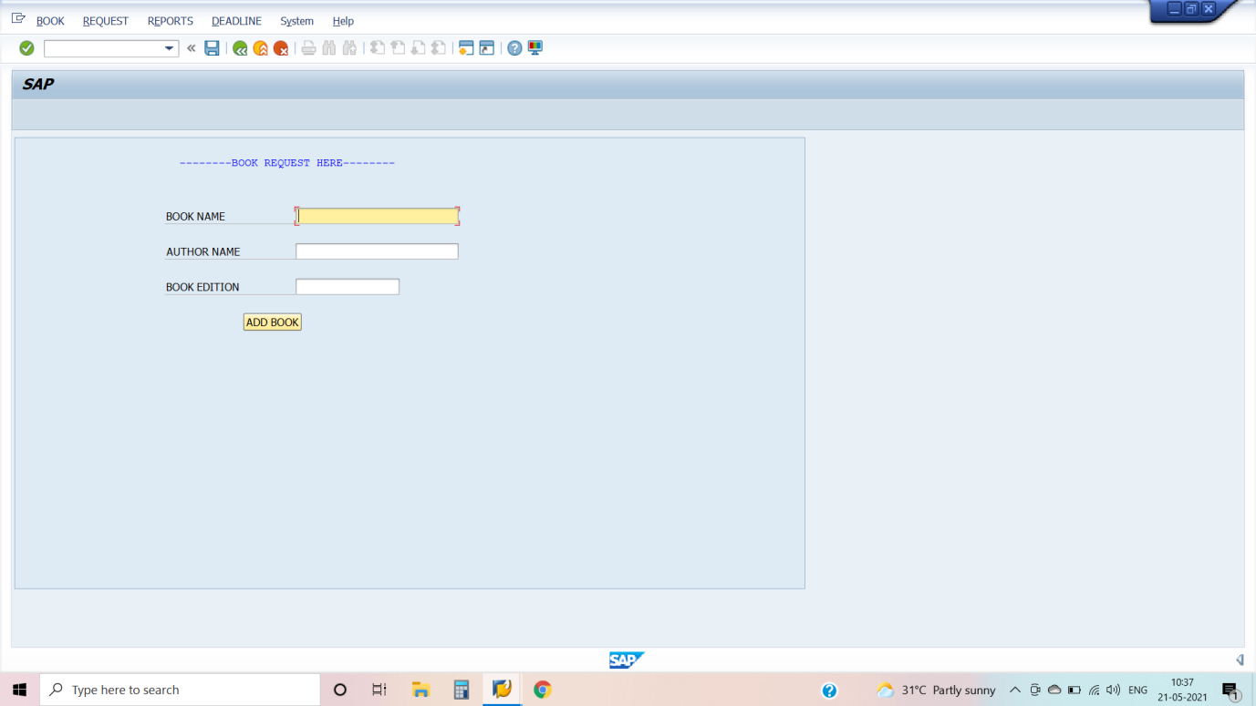

**5.3 Book Search**

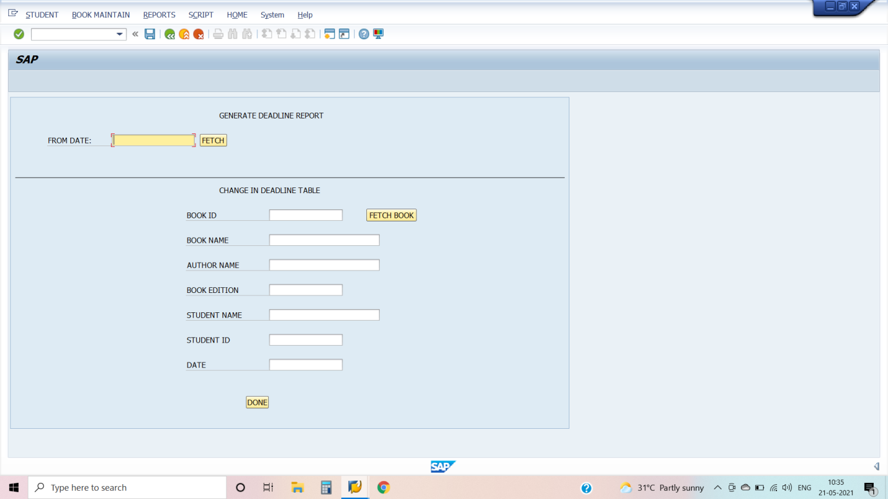

**5.4 Deadline screen**

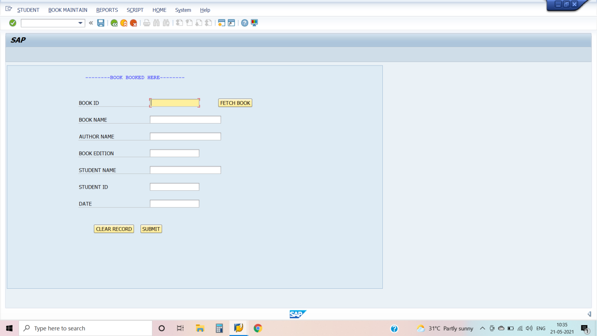

**5.5 Book Booked screen**

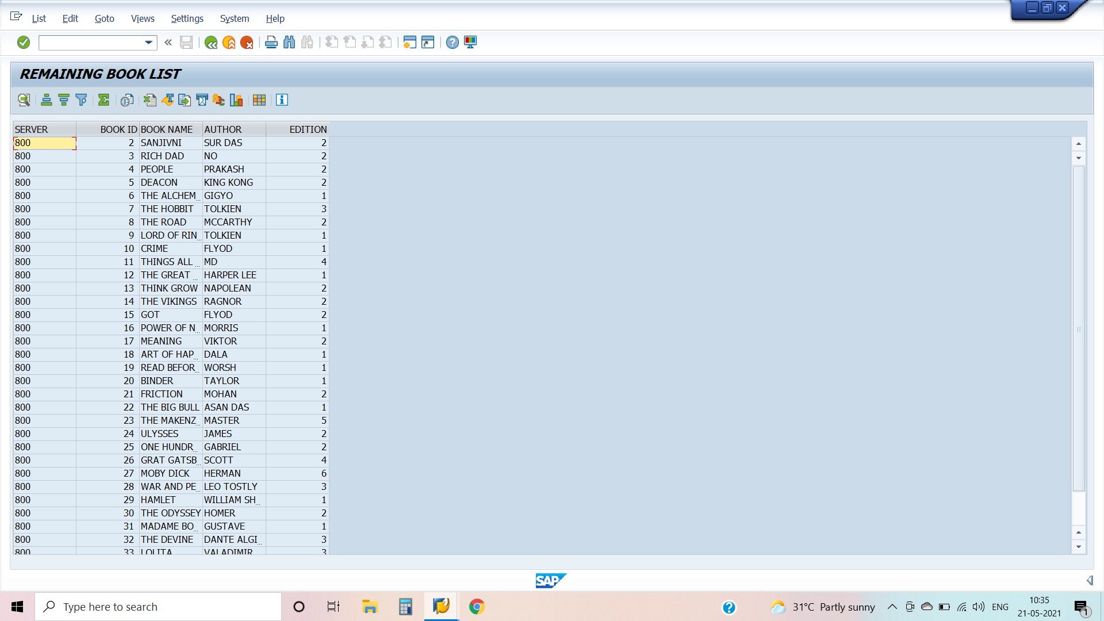

**5.6 Remain Book report screen**

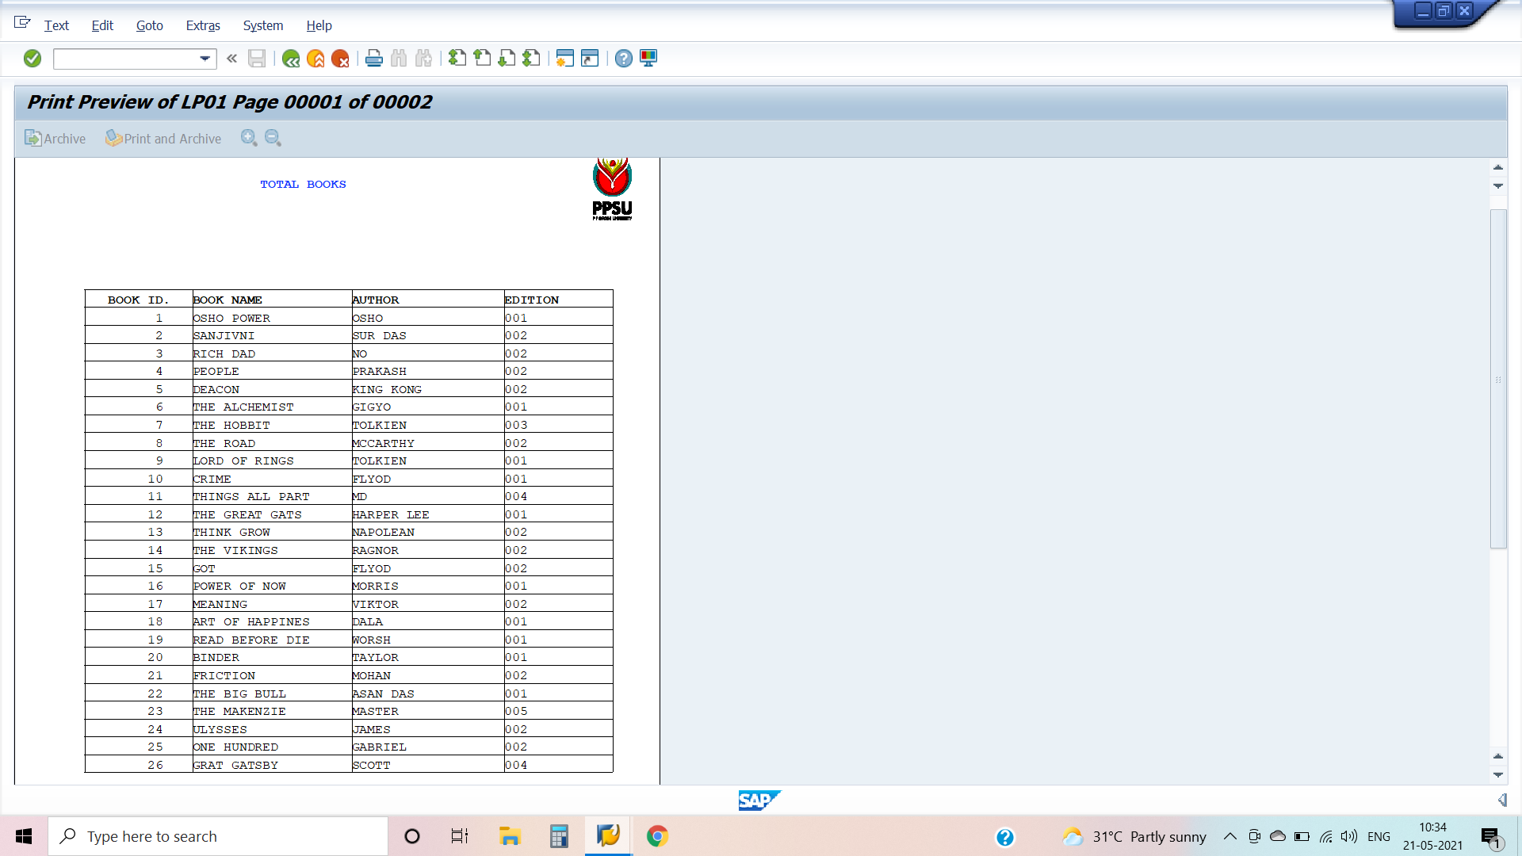

**5.7 Total Book print option (Smartforms)**

CHAPTER 6

**CONCLUSIONS AND FUTURE SCOPE**

This SAP System provides a computerized version of library management system which will benefit the students as well as the staff of the library. It makes entire process online where student can search books, staff can generate reports and do book transactions. It also has a facility for student login where student can login and can see status of books issued as well request for book or give some suggestions. It has a facility of teacher’s login where teachers can add lectures notes and also give necessary suggestion to library and also add info about workshops or events happening in our college or nearby college in the online notice board.

**REFERNCES**

* https://help.sap.com/viewer/index